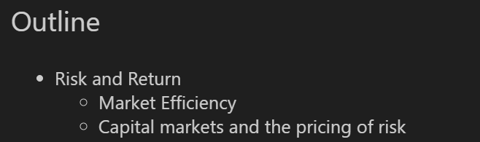

1. **Capital Markets and Pricing of Risk**

* Capital markets react to events like war, inflation, and uncertainty.
* Investors respond through **“flight to quality”**: moving to safer assets (e.g. USD, gold).
* Volatility indexes (std.dev) (e.g. VIX) inc when risk increases.

1. **The Efficient Market Hypothesis (EMH)**

* **The weak-form:** Stock prices already reflect all information that can be derived by examining market trading data such as the history of past prices, trading volume, or short interest. (past data).
* **The semistrong-form:** All publicly available information regarding the prospects of a firm must be reflected already in the stock price.
* **The strong-form:** Stock prices reflect all information relevant to the firm, even including information available only to company insiders.

1. **Probability Distribution, Expected Return**

* Each possible return has a **probability**.
* **Expected Return** = weighted average of possible outcomes.

|  |
| --- |
| $$E\left[R\right]=\sum_{R}{P_{R}* Possible Return (R)}$$ |

1. **Risk Measures: Variance & Standard Deviation**

|  |
| --- |
| $$Var\left(R\right)=ΣP_{R}*{\left(R- E\left[R\right]\right)}^{2}=E[{\left(R-E\left[R\right]\right)}^{2}]$$ |
| $$Std.dev(R)=\sqrt{Var (R)}$$ |

* Variance measures how spread out returns are.
* Standard Deviation (Volatility) = root of variance.
* These are core measures of risk in portfolio management (quản lí danh mục đầu tư).

1. **Historical Returns: Arithmetic vs. Geometric**